Binary Search Tree ban đầu:

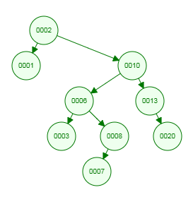

Binary Search Tree sau khi thêm 14, 0, 35:

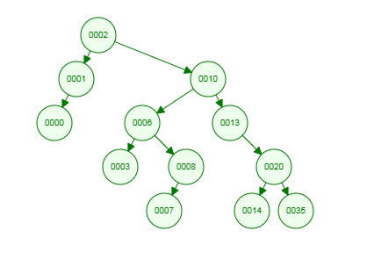

Binary Search Tree sau khi xóa 6, 13, 35:

